**DWDM LAB MODEL**

**NAME:A.KISHORE RAGUL**

**ROLL NO:18BCS066**

**LIST the ATTRIBUTES AND ITS TYPES:**

**1.Sepal.length – Numeric 2**

**2.Sepal.width – Numeric 3**

**3.Petal.length – Numeric 4**

**4.petal.width – Numeric 5**

**5.Variety - Nominal**

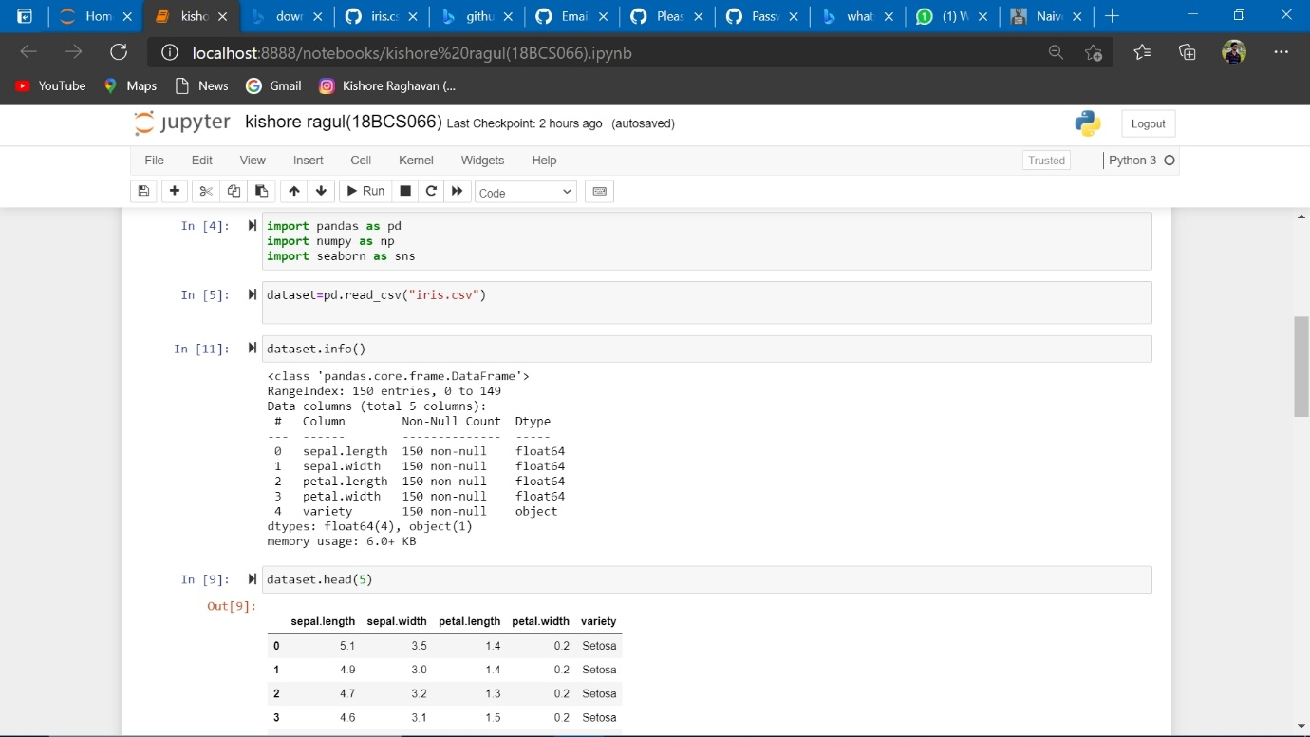

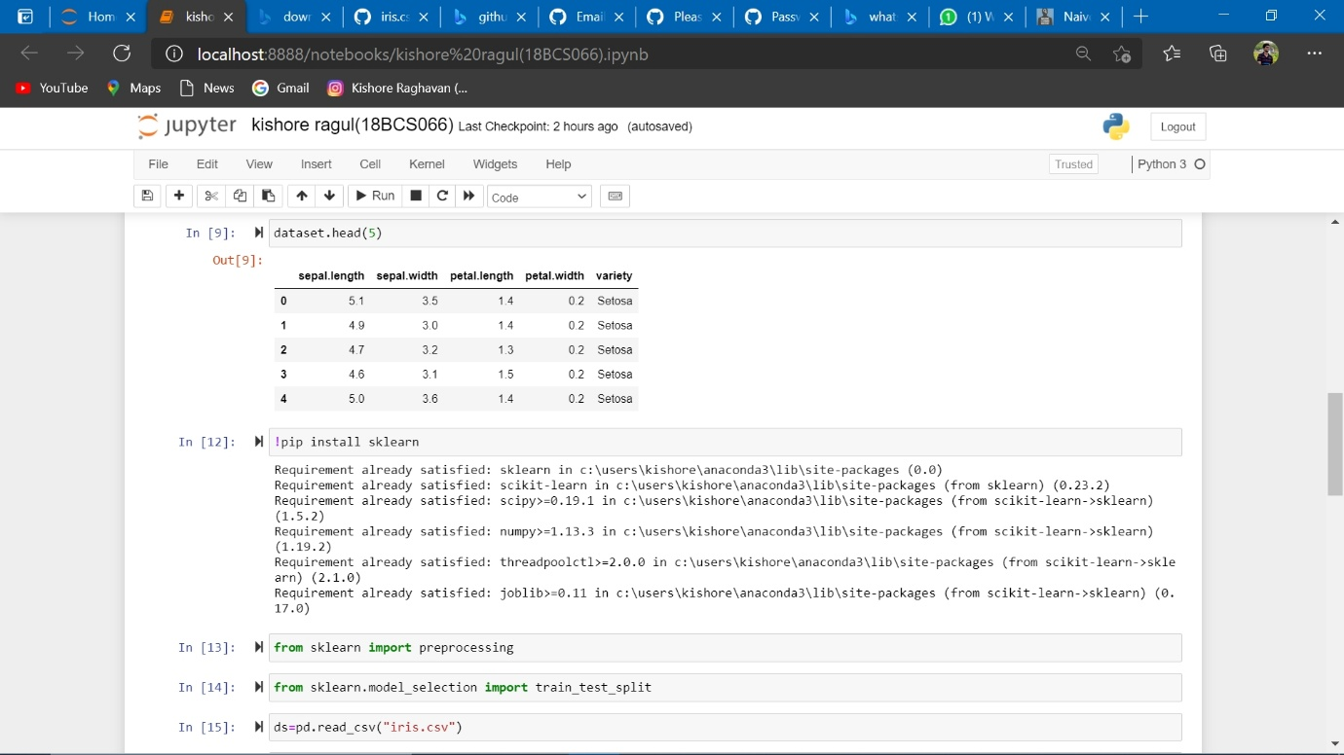

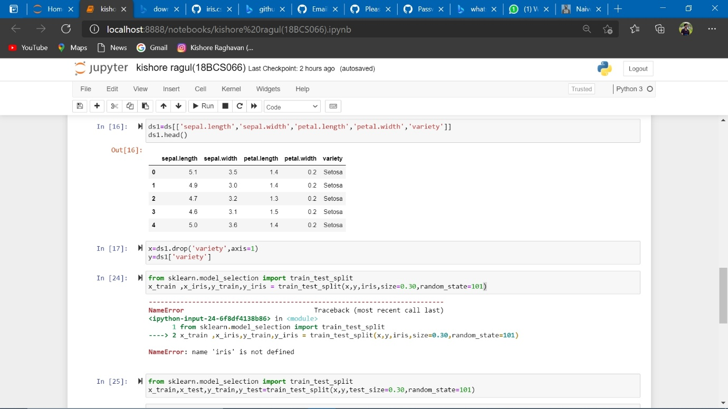

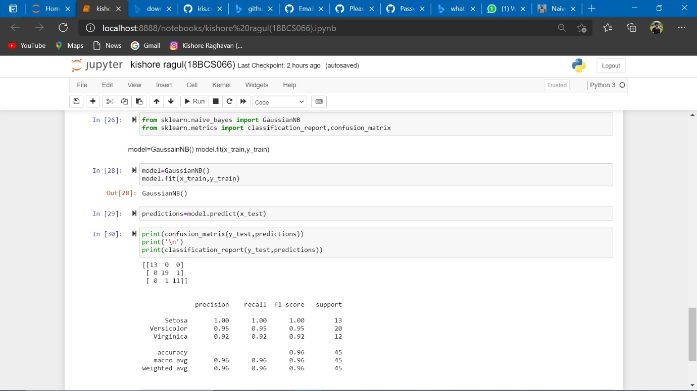

...

GITHUB LINK: